**Article ID:** 1169

**Article Name:** How can I find a specific User Manual?

**Topic Location:** Laundry / Washing Machine/

**Meta-data:** product, model, code, manual, guide, book, instruction

**Related Articles:**

**Related Questions:**

PNC

DIY

Safety

Link

Email

Book Engineer

Multimedia

Brand

**Article Content:**

To find a User Manual you have to know the model reference and product number of your appliance. You can find this information on the rating plate indicate as indicated below.

Once you have this information please click on the link below

[User Instruction Manual website](http://www.electrolux-ui.com/)

Where is Product Number Code (PNC) and model of the washing appliance?

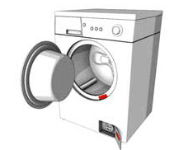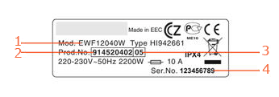

|  |  |
| --- | --- |
| 1. Model number | 3. ML code |
| 2. Product number code (PNC) | 4. Serial number |

1169_01_How_to_find_a _User_Manual-JAT-13-12-10.jpg

1169_02_How_to_find_a _User_Manual-JAT-13-12-10.jpp